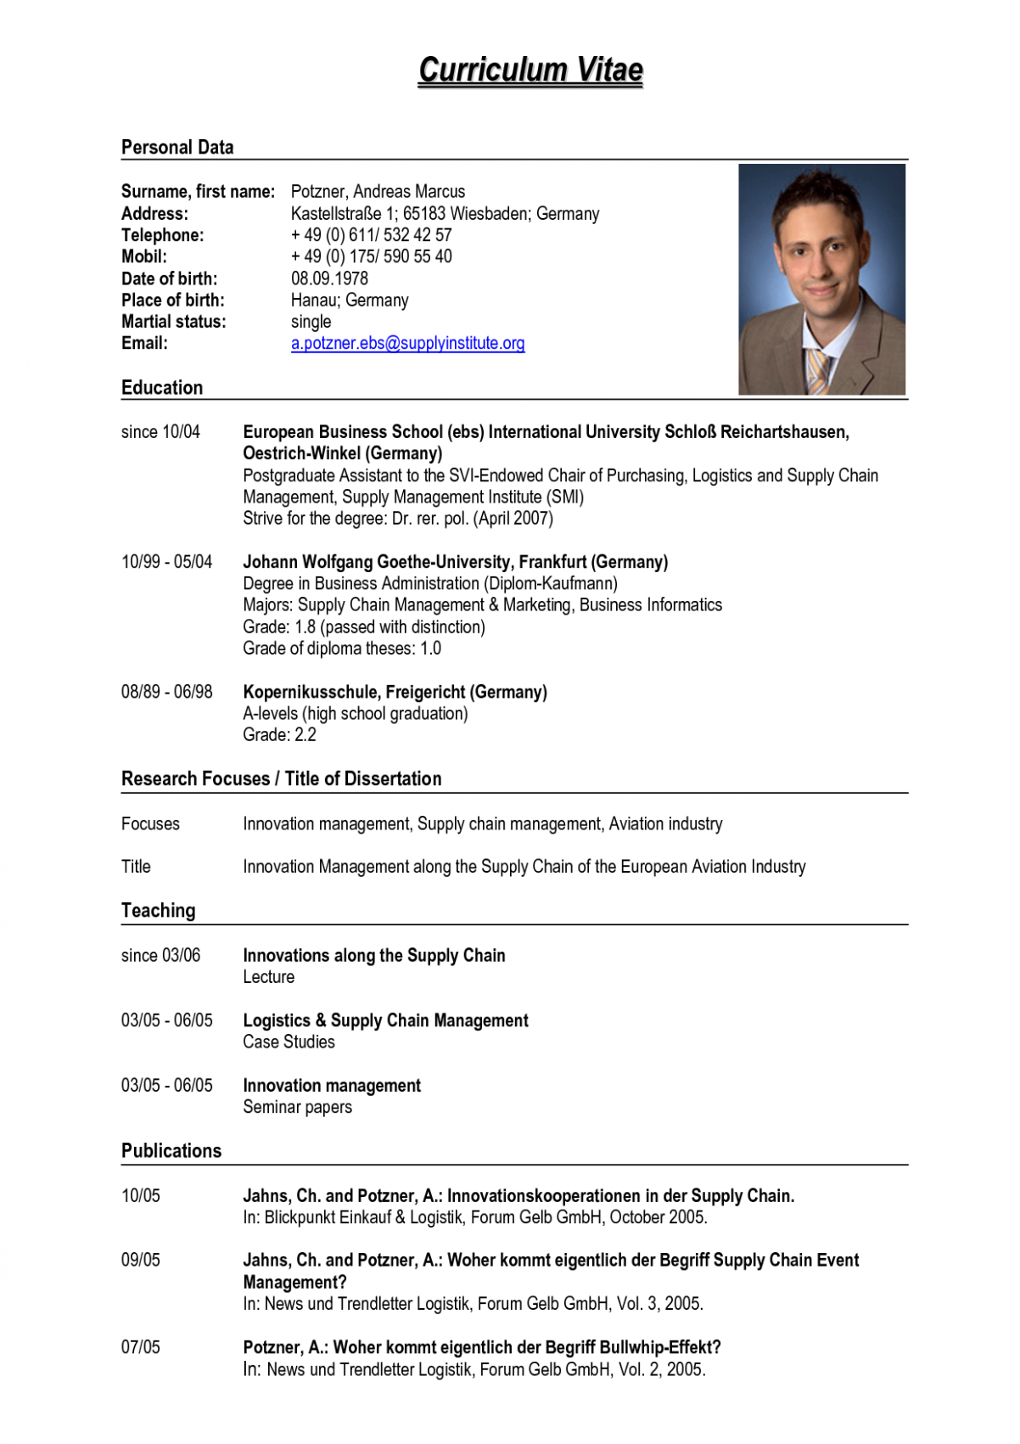

*Curriculum Vitae*

**Personal Data**

Surname, first name: Potzner, Andreas Marcus Address:

Kastellstraße 1; 65183 Wiesbaden; Germany Telephone:

+49 (0) 611/ 532 42 57 Mobil:

+49 (0) 175/ 590 55 40 Date of birth: 08.09.1978 Place of birth: Hanau; Germany Martial status: single Email:

a.potzner.ebs@supplyinstitute.org

**Education**

since 10/04

European Business School (ebs) International University Schloß Reichartshausen, Oestrich-Winkel (Germany) Postgraduate Assistant to the SVI-Endowed Chair of Purchasing, Logistics and Supply Chain Management, Supply Management Institute (SMI) Strive for the degree: Dr. rer. pol. (April 2007)

10/99 - 05/04

Johann Wolfgang Goethe-University, Frankfurt (Germany) Degree in Business Administration (Diplom-Kaufmann) Majors: Supply Chain Management & Marketing, Business Informatics Grade: 1.8 (passed with distinction) Grade of diploma theses: 1.0

08/89 - 06/98

Kopernikusschule, Freigericht (Germany) A-levels (high school graduation) Grade: 2.2

**Research Focuses / Title of Dissertation**

Focuses

Innovation management, Supply chain management, Aviation industry

Title

Innovation Management along the Supply Chain of the European Aviation Industry

**Teaching**

since 03/06

**Innovations along the Supply Chain Lecture**

03/05 - 06/05

Logistics & Supply Chain Management Case Studies

03/05 - 06/05

Innovation management Seminar papers

**Publications**

10/05

Jahns, Ch. and Potzner, A.: Innovationskooperationen in der Supply Chain. In: Blickpunkt Einkauf & Logistik, Forum Gelb GmbH, October 2005.

09/05

Jahns, Ch. and Potzner, A.: Woher kommt eigentlich der Begriff Supply Chain Event Management? In: News und Trendletter Logistik, Forum Gelb GmbH, Vol. 3, 2005.

07/05

Potzner, A.: Woher kommt eigentlich der Begriff Bullwhip-Effekt? In: News und Trendletter Logistik, Forum Gelb GmbH, Vol. 2, 2005.